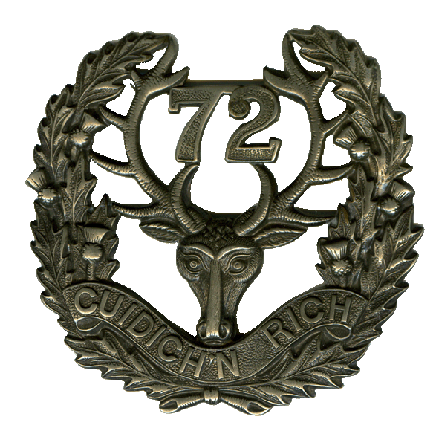

The Commanding Officer of
72nd Seaforth Highlanders of Canada
requests the pleasure of your company at the

102 Annual Ceremonial Review
June 9th, 2015
Ceremony at 6:45 pm

Bessbourough Armouries Serving Members: 1A with Medals
2040 West 11th Avenue, Vancouver Civilians: Business Attire

